**Lecture: Role Based Tasks**

As we talk about and use roles, let's demonstrate the major areas and functions one at a time.

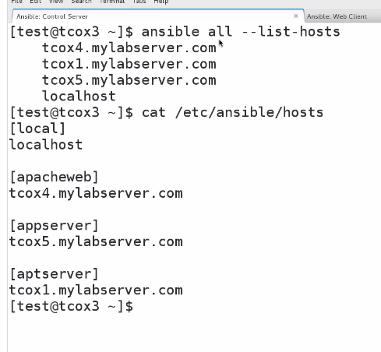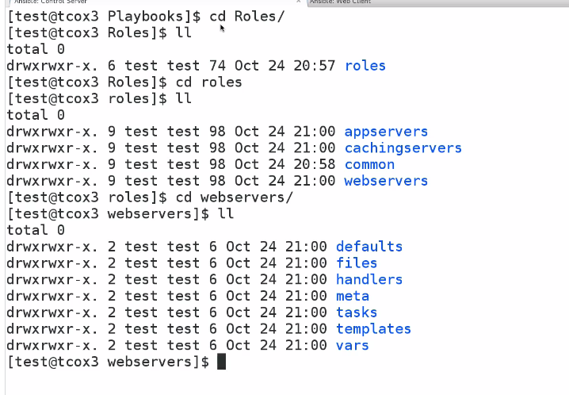

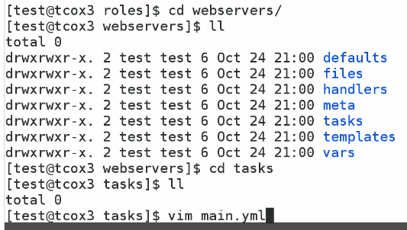

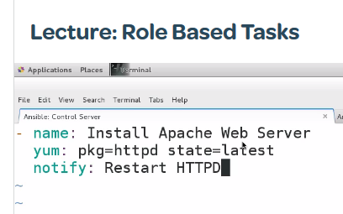

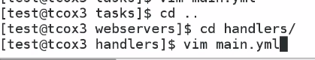

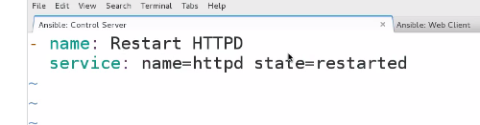

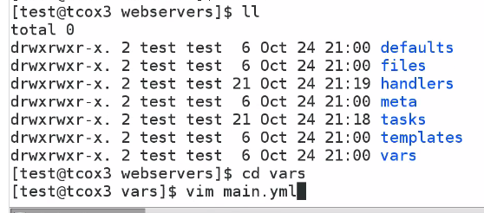

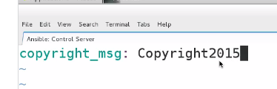

Now go to the top level directory to create master playbook

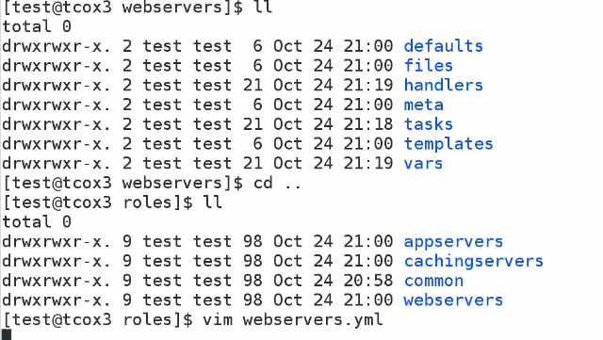

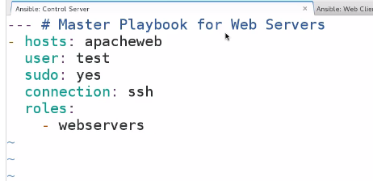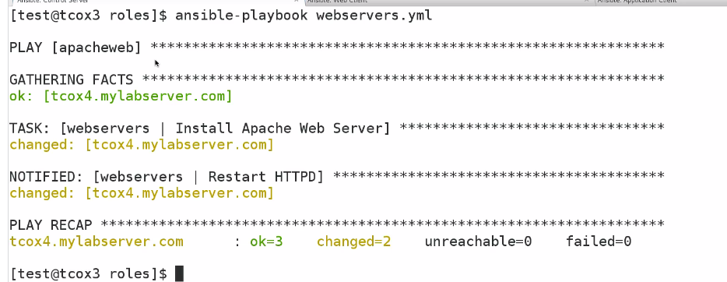

## Exercise: Roles - Tasks Within a Role

1. Verify that your ansible installation is available by displaying the version of ansible while logged in as the 'user' user.

[test@tcox3 ~]$ ansible --version

ansible 1.9.2

  configured module search path = None

2. Run the ansible command that lists all of the hosts configured in your control server 'hosts' file for the system.

[test@tcox3 ~]$ ansible all --list-hosts

    tcox5.mylabserver.com

    localhost

    tcox4.mylabserver.com

3. Create a directory structure using the content directions from the Roles series and in our previous exercises, in the subdirectory called 'tasks' do the following:

- Create a YAML File called 'main.yml'

- Add two named tasks to that file that install two packages (of any kind)

- Create a top level playbook called 'webservers.yml' that has the appropriate user (test), sudo rights, gathering facts set to no and runs over SSH and includes the 'webservers' role we created earlier

  whose 'tasks' directory we added the main plays to in the above step.

[test@tcox3 roles]$ vim webservers/tasks/main.yml

[test@tcox3 roles]$ cat webservers/tasks/main.yml

- name: Install (Red Hat/CentOS) Apache Web Server

  yum: pkg=httpd state=latest

- name: Install (Red Hat/CentOS) Apache Web Server

  yum: pkg=telnet state=latest

4. Run the playbook and display the results.

[test@tcox3 roles]$ ansible-playbook webservers.yml

PLAY [apacheweb] **************************************************************

GATHERING FACTS ***************************************************************

ok: [tcox4.mylabserver.com]

TASK: [When did the ROLE start] ***********************************************

ok: [tcox4.mylabserver.com]

TASK: [redhat_webservers | Install (Red Hat/CentOS) Apache Web Server] ********

ok: [tcox4.mylabserver.com]

PLAY RECAP ********************************************************************

tcox4.mylabserver.com      : ok=2    changed=0    unreachable=0    failed=0